Review paper 144 STACS 2022

**Overall evaluation.**\* Please provide a detailed review, including a justification for your scores. Both the score and the review text are required.

The authors present a multi-objective tabu search implementation in which neighborhood is selected with quantum gates. The multi-objective optimization problem is explained to be a choice of teleportation on virtual machines to other hosts with several objectives such as the reliability of the system, the electric power, the load of the critical communication node and the workload of the bottleneck CPU.

The authors present in the state of the art the first tabu search algorithms for multi objectives optimization problem, an also some paper treating the neighborhood with quantum gates.

I don’t really understand what is the point of using quantum gates. Is it a generator of a subset of the neighborhood ?

The formal optimization problem is then described and it is explained that authors have implement it on openstack plateform, with a virtual cloud between Gdansk University and Warsaw University). It looks like the only novel point of this article is to implement the quantum algorithms on technical plateforms, and no algorithmic contribution is given

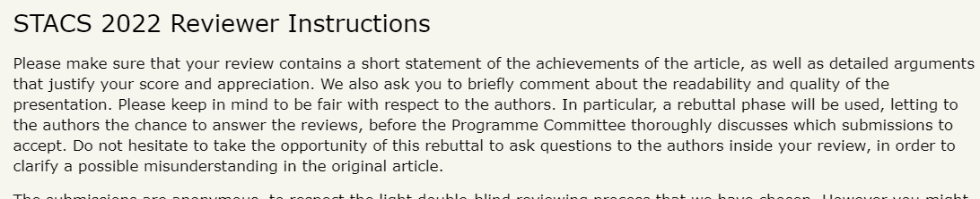

**Confidential remarks for the program committee.** If you wish to add any remarks intended only for PC members please write them below. These remarks will only be seen by the PC members having access to reviews for this submission. They will not be sent to the authors. This field is optional.